**Our Lady of the Lakes Catholic Community**

**Registration for 1st Holy Communion\***

*Anyone preparing for sacraments needs to have completed a full year of Religious Education (either through a Catholic school or parish religious ed. program) and be currently enrolled. Candidates for this sacrament also need to have prepared for and celebrated the Sacrament of Penance & Reconciliation.

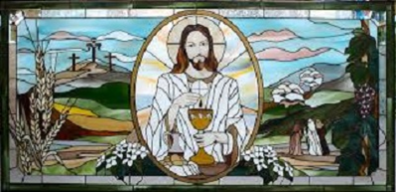

**Print legibly & return to the Parish Center\*\*** Today’s date: ________

**Candidate’s Full Name:** ____________________________________ School & Grade: ________________________

**Place & DOB: ___________________________________________**

**Name of church & place where baptized**: _________________________________________________

(If not in OLOL, please provide a copy of the child’s Baptismal Certificate, if not already provided.)

**Currently receiving religious education through** (please circle one):

OLOL Family Faith Formation St. Michael’s/other Catholic School Home Schooled

**Prepared for** Reconciliation/Confession/Penance at**:** __________________________________ Year: ___________

**Mass family usually attends (Time & location)**: _________________________________________________________

**Parents’/guardians’ Legal Names**: _____________________________________________________________ (Mom, include Maiden Name)

Best way to contact: **Mom’s Phone**: ____________________ **Email**: ____________________________________

**Dad’s Phone**: ________________________________ **Email**: ________________________________________

Family Address: __________________________________________________________________________________

The fee for this preparation is $30.00. Please send a check payable to OLOLCC along with this form. Memo= Eucharist Prep.

Parents submitting this form will be sent an email requesting available dates, times and method of delivery for this preparation. Celebration of the sacrament is usually where the family worships, during the Easter season. Contact Patty Larzelere by email or at the number below with questions/concerns.

We, the OLOL staff, look forward to preparing your child(ren). Peace be with you.

** 210 Keuka St., Penn Yan, NY 14527 315-536-7459