The Season of Creation (9/1-10/4), is sponsored by the World Council of Churches. It is a time to renew our relationship with each other, our Creator and all creation through celebration, conversion, and commitment together. This year’s theme:
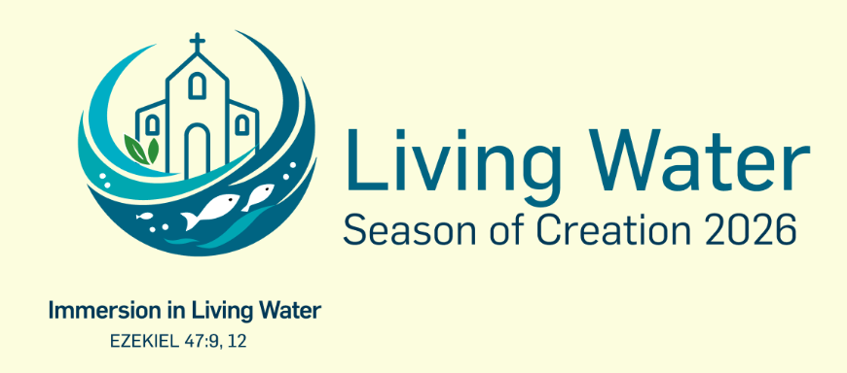
OLOLCC invites you to join us in celebrating the Season of Creation (9/1-10/4)!
View the online kick-off prayer service on 9/1. Daily pray “Care For God’s Creation.”
For the littles among us, view Patty reading, “The Last Straw, Kids vs. Plastics” by Susan Hood. (On Zoom: https://us06web.zoom.us/rec/share/gnCXjuWxoyGumq6x4XDDPYajb_2dUCRFn0kqzHA2aYzeYMFH71PTM8588xQy-Fu8.6Bpr85nE2QNCp4yM Passcode: QrV6s=9=
At Mass every weekend, Care of Creation intentions will be part of the Prayers of the Faithful.
The "Creation Sings" art competition is open to all youth, K-12. (Deadline to submit is 9/25/26.)
Join in a nature walk, 2PM on 9/20 at Grimes Glen, Naples.
In conjunction with the Jubilee Year of St. Francis of Assisi (800th anniversary of his death), Fr. Leo will offer the Care of Creation Mass on Saturday, 10/3 at 9AM in the Chapel of St. Michael's. After Mass, all participants are invited to a continental breakfast in the Hall. From 10-11:30AM, a spiritual and educational program will be offered. It is designed to assist you, your family, our parish & school to learn, grow & respond to the Church’s teaching on caring for creation & how to take action to protect our common home as a community of faith. Please call 315-536-7459 to register by 9/28.
Teens and adults can read, “The Problem With Plastics.” View the webinar on 9/10, 7PM. Register for the discussion as follows: