Registration for RECONCILIATION*

*Anyone preparing for sacraments needs to have completed a full year of Religious Education (either through a Catholic school or parish religious ed. program) and be currently enrolled in the school/religious ed. program.

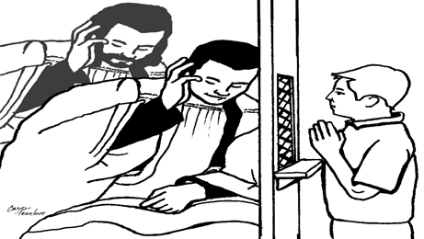

**Print legibly & return to the Parish Center\*\***

**Candidate’s Full Name:** _____________________________________ School & Grade: ________________________

**Place & DOB:** ______­­­­­­­­­­­­­­­­­­­­­­______________________________________________

**Name of church & place where baptized**: __________________________________________

(If not in OLOL, please provide a copy of the child’s Baptismal Certificate.)

**Mass family usually attends (Time & location)**: ________________________________________________________

**Currently receiving religious education through** (please circle one):

OLOL Family Faith Formation St. Michael’s/other Catholic School Home Schooled

**Parents’/guardians’ Legal Names**: __________________________________________________________________

(Mom, please include Maiden Name)

Best way to contact you: **Mom’s Phone**: _____________________ **Email**: ______________________________

**Dad’s Phone**: ________________________________ **Email**: _______________________________________

Family Address: _________________________________________________________________________________

The dates, times and method of delivery of the classes will be based on results of surveys sent to parents who are completing this form. Look for it in a subsequent email. Contact Patty at [patricia.larzelere@dor.org](mailto:patricia.larzelere@dor.org) with any questions or concerns.

Please include the $30pp fee with this form. The address below is below. Please mark Reconciliation Prep on your check.

We, the OLOL staff, look forward to preparing you and your child/ren. Peace be with you.

** 210 Keuka St., Penn Yan, NY 14527 315-536-7459